Testing Report

By

Mansoor Munawar

# **Overview**

# I will be carrying out unit test on the code supplied by the developer who left the organization. This is to make sure the code can work as intended without breaking down. I will also be carrying out integration tests to see how different methods interact within one another. This is done so that we can check whether the method not only works individually but also part of group. The integration test will be done via white box test and a Blackbox test by including a screenshot of the outcome. Finally, we will carry out the system test using a Blackbox test and see how the code runs when valid test data is entered from start to finish.

The benefit of testing is to make sure there are no bugs in the software which might otherwise not have been identified. Therefore, we will use a wide variety of test cases from valid, abnormal to extreme test data so that we can cover all the scenarios whereupon the software might have broken down or crashed. Although some errors such as syntax are easily identifiable by the compiler, errors such as logic and run time error might have been missed if not for various testing methods.

# **Unit Testing**

I will be carrying out unit tests on the login method to make sure the code works as intended and does not crash the program. I will use a test log sheet to record the test results, and this will be carried out by using the white-box test technique.

**White box test:**

|  |  |  |  |  |  |  |
| --- | --- | --- | --- | --- | --- | --- |
| **Method Name** | **Test Case Description** | **Test Data** | **Expected Result** | **Actual Result** | **Action Taken** | **Comments** |
| login | User enters the correct password and is validated | “clyderunners” | Message displayed to the user “Password validated” | Pass | n/a | n/a |
| login | User enters incorrect data | “clyde123” | Message displayed to the user “incorrect password entered  You have 2 attempts left | pass | n/a | n/a |
| login | User enters incorrect data | “1.2” | Message displayed to the user “incorrect password entered  You have 2 attempts left | pass | n/a | n/a |
| login | User enters incorrect data | “-1” | Message displayed to the user “incorrect password entered  You have 2 attempts left | pass | n/a | n/a |
| login | User enters incorrect data three times | “clyde123”, “1.2”, “-1” | Message displayed to the user “incorrect password entered  You have 2 attempts left”,  Message displayed to the user “incorrect password entered  You have 1 attempts left”,  Message displayed to the user “incorrect password entered  You have 0 attempts left”  “Number of attempts exceeded you are now locked out.” | pass | n/a | n/a |

# **Integration Testing**

Integration tests are carried out by testing different methods of the program and how they work as part of the group. This is done to make sure that the data transfer between each method works as intended. I will use a white-box test and record the result on the test log sheet.

**Integration Tests:**

**White Box:**

|  |  |  |  |  |  |  |
| --- | --- | --- | --- | --- | --- | --- |
| **Method Name(s)** | **Test Case Description** | **Test Data** | **Expected Result** | **Actual Result** | **Action Taken** | **Comments** |
| Login  Menu | Users enters correct password and is displayed with the main menu | “Clyderunners | Message displayed to the user “Password validated”  And the user is shown the main menu screen with the sub menus | Pass | n/a | n/a |
| Menu  readFile | User is shown the main menu and seleccts option 1 to go to read and display file | “1” | User is shown the main menu  After selecting option 1 user is displayed with the 2D array of all the names of runners with the time. Also a text file is created on the system with the same information.  The user returns to the main menu | pass | n/a | n/a |
| read  Sort | User is shown the main menu and selects option 1 to go to read file and display runner's time.  Once the user is returned to main menu the user selects option 2 to go to sort section | “1”, “2” | User is shown the main menu  After selecting option 1 user is displayed with the 2D array of all the names of runners with the time. Also a text file is created on the system with the same information.  The user returns to the main menu  After selecting option 2 user is displayed with the 1D array of all the runners time from slowest to the fastest. Also a text file is created on the system with the same information.  The user returns to the main menu | pass | n/a | n/a |

**Black box test result:**

**Login method and how it interacts with Menu Method**

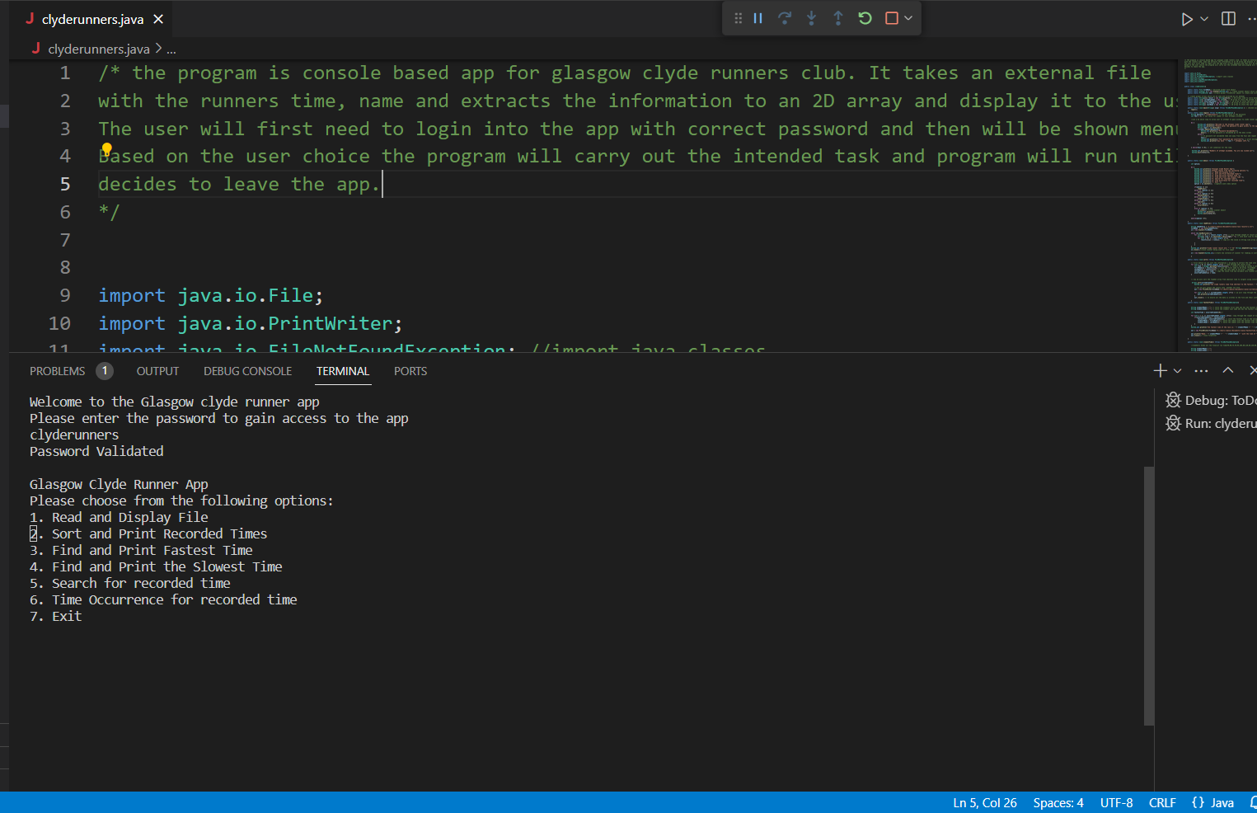

**Menu method and how it interacts with the readFile method**

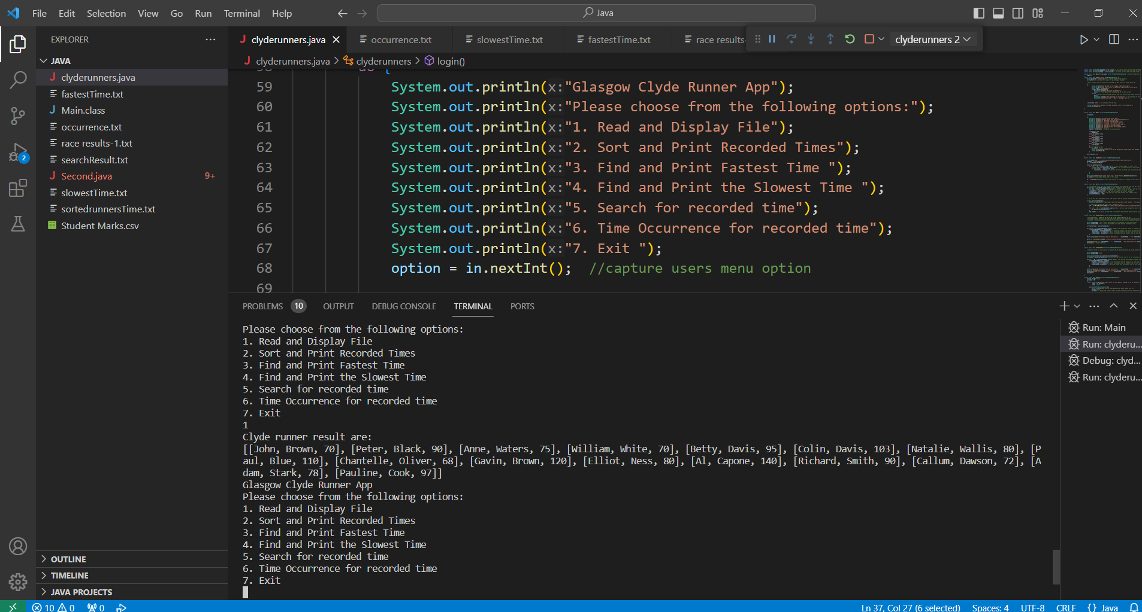

**Read method and how it interacts with Sort method**

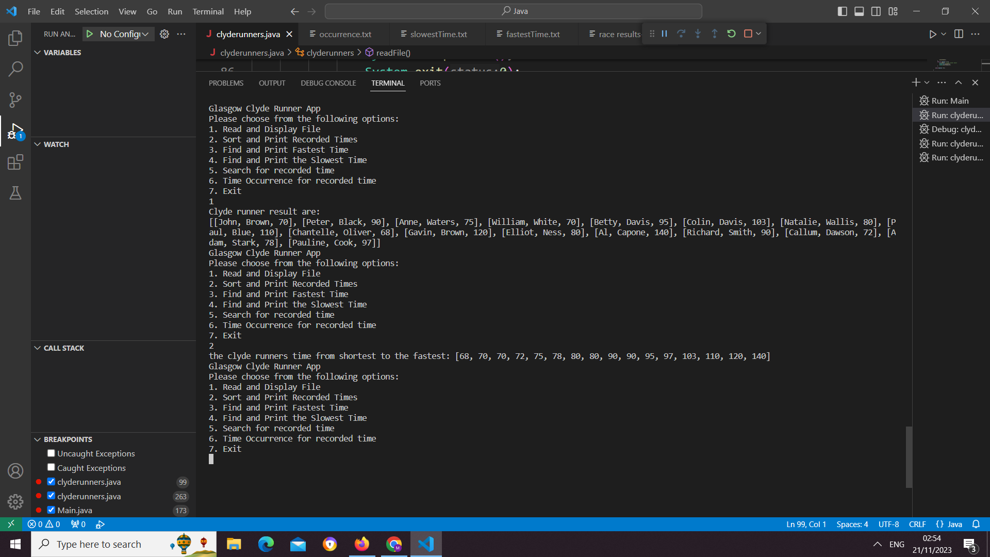

# **System Tests**

# System tests are carried out to make sure the program works as intended from the start to the finish. I will be using black box testing technique to carry out system test and will be using valid test data.

**System Test: (Valid Data)**

**Description:**

User will login into the app by entering the correct password, user will be shown the main menu and will select option 1 to read the file, then the user will be shown the 2D array of all the runners name and time. User will return to the main menu and then select option 2 to go to the sort option where the user will be shown 1D array of all the runners time from slowest to the fastest. The user will then select option 7 to exit the program and will be displayed with appropriate message.

**Steps needed:**

* User is promoted to enter password
* User enters “clyderunners”
* Main menu is displayed and asked to select a choice
* User enters choice 1
* user will be shown the 2D array of all the runners name and time as well as text file saved onto the computer
* User returns to main menu and asked to select a choice.
* User enters option “2”
* User will be shown 1D array of all the runners time from slowest to the fastest
* User returns to main menu and asked to select a choice.
* User enters option “7”
* exit the program and will be displayed with message “Thank you for using the Glasgow Clyde Runner App. Goodbye..."

**Black Box Result:**

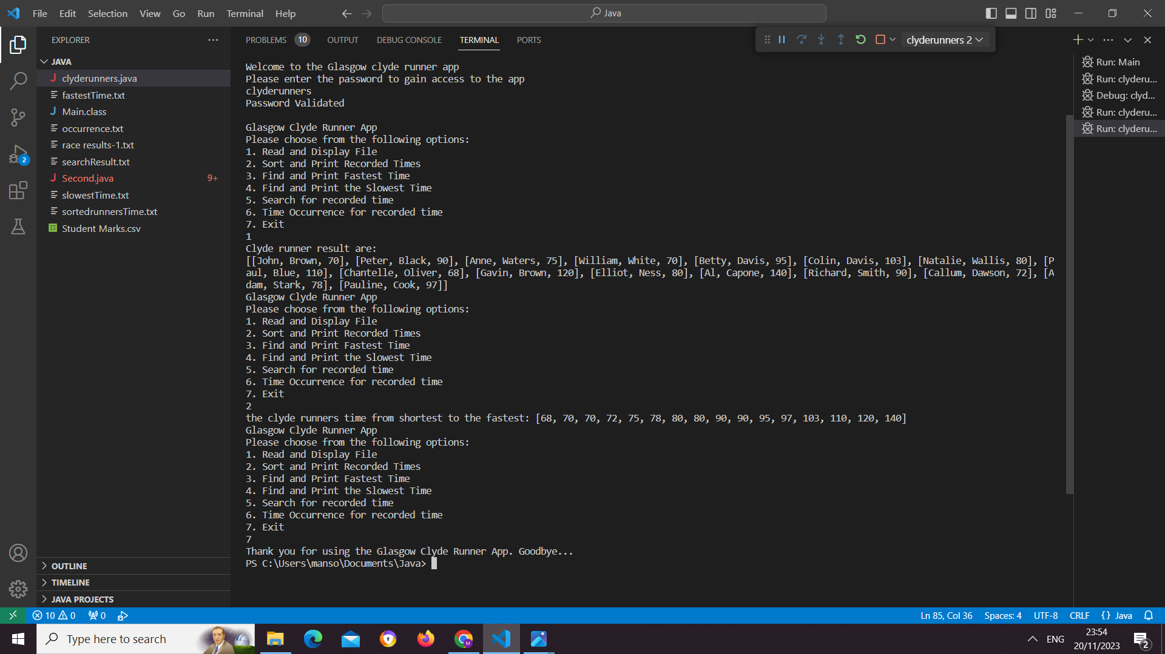

**Trace Table:**

I will be carrying out a dry run on the fastest time method and record the result using a trace table. I have attached the screenshot of the fastest time method, and the result are copied into the trace table. I have found that the program works as intended and correct output is displayed to the end user.

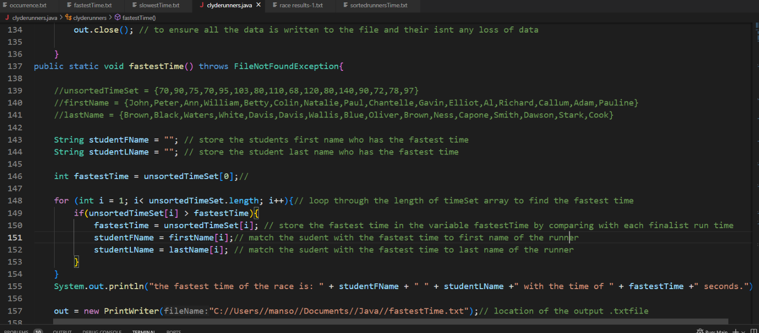

**Trace Table**

|  |  |  |  |  |  |  |  |
| --- | --- | --- | --- | --- | --- | --- | --- |
| Step | fastestTime | i | unsortedTimeSet[0] | unsortedTimeSet[I] | firstName[I] | LastName[I] | Output |
| 1 | 70 |  | 70 |  |  |  |  |
| 2 | 90 | 1 |  | 90 | Peter | Black |  |
| 3 |  | 2 |  | 75 |  |  |  |
| 4 |  | 3 |  | 70 |  |  |  |
| 5 | 95 | 4 |  | 95 | Betty | Davis |  |
| 6 | 103 | 5 |  | 103 | Colin | Davis |  |
| 7 |  | 6 |  | 80 |  |  |  |
| 8 | 110 | 7 |  | 110 | Paul | Blue |  |
| 9 |  | 8 |  | 68 |  |  |  |
| 10 | 120 | 9 |  | 120 | Gavin | Brown |  |
| 11 |  | 10 |  | 80 |  |  |  |
| 12 | 140 | 11 |  | 140 | Al | Capone |  |
| 13 |  | 12 |  | 90 |  |  |  |
| 14 |  | 13 |  | 72 |  |  |  |
| 15 |  | 14 |  | 78 |  |  |  |
| 16 |  | 15 |  | 97 |  |  |  |
| 17 | 140 |  |  |  | Al | Capone | Al Capone 140 |

# **Debugging**

Debugging is identifying and resolving any potential issue within the software. I plan to debug my code using a built-in java debugger by adding a breakpoint into the code where I would like to either step into the code or step over the code. I intend to use it on the for loops to make sure the logic within the loop is correct, I.e checking to see if loop is within the bound of the array and does not crash the system. Also, if I have any errors that are logic based or run time errors then using debugger and applying the breakpoint can help to resolve the issue within the code.

Please add screen show below to show that you have used a break point inside your Integrated Development Environment to debug your program:

